

19CSE312 Distributed Systems

Algorithmic Improvements in the Chandy-Mishra-Haas AND Model

| **Roll Number** | **Name** |
| --- | --- |
| CB.EN.U4CSE22424 | N Sai Kiran Varma |
| CB.EN.U4CSE22440 | Soma Siva Pravallika |
| CB.EN.U4CSE22444 | Suman Panigrahi |
| CB.EN.U4CSE22457 | Sravani Oruganti |

# 1. Introduction

Deadlock detection and resolution are challenging aspects of distributed systems. The traditional Chandy-Misra-Haas (CMH) AND model uses probe-based edge chasing on wait-for graphs—where processes may wait on several resources simultaneously—to detect cycles that indicate deadlocks. Although conceptually robust, this reactive method depends on individual processes initiating detection based on suspicion. This can result in inefficiencies and missed detections. Furthermore, the traditional model is susceptible to issues such as message loss, limited state management, and low observability, especially under dynamic real-world conditions.

This case study presents an enhanced implementation that integrates elements of **Distributed Depth-First Search (DDFS)** with the traditional CMH approach. Key improvements include robust acknowledgment handling, session-based state management to separate concurrent detection rounds, and proactive probe initiation. Enhanced logging and configurability further improve observability and deployment simplicity. These enhancements yield a more dependable and efficient deadlock detection system while addressing core shortcomings of the conventional method.

# **2. Objectives**

* **Understand** the mechanics and limitations of the traditional CMH algorithm.
* **Implement** proactive deadlock detection via periodic probe initiation.
* **Introduce** session-based tracking for managing multiple concurrent detection rounds.
* **Enhance** message reliability using acknowledgment channels and timeout-based retries.
* **Integrate** detailed logging and metrics for improved observability.
* **Enable** configurability and graceful shutdown for robust deployment.
* **Compare** the traditional and hybrid approaches regarding effectiveness, message overhead, and adaptability.

# **3. Traditional AND Model: Chandy-Misra-Haas Simulation in Go**

## **3.1. Overview**

The traditional Chandy-Misra-Haas algorithm is a distributed deadlock detection method. Each process sends probe messages along its waiting-for edges. A cycle is detected when a probe returns to its originator. Despite its fully distributed nature, this method incurs significant message overhead and struggles with dynamic system changes.

## **3.2. Code Implementation**

Below is a Go simulation of the CMH algorithm. This simple simulation models a system with three processes that form a cyclic wait-for relationship:

package main

import (

"fmt"

)

// Process represents a process in the system.

type Process struct {

id int

waitingFor []int

receivedProbes map[int]bool

}

// sendProbe sends a probe message to a dependent process.

func sendProbe(probeSender int, origin int, target int, processes map[int]*Process) bool {

fmt.Printf("Probe sent from Process %d to Process %d for origin %d\n", probeSender, target, origin)

// If the target process is waiting for other processes, forward the probe.

if len(processes[target].waitingFor) > 0 {

for _, dependent := range processes[target].waitingFor {

// Check if the probe has returned to the origin.

if dependent == origin {

fmt.Println("Deadlock detected involving process", origin)

return true

}

if !processes[target].receivedProbes[dependent] {

processes[target].receivedProbes[dependent] = true

if sendProbe(target, origin, dependent, processes) {

return true

}

}

}

}

return false

}

// detectDeadlock initiates deadlock detection from each process.

func detectDeadlock(processes map[int]*Process) {

for id, process := range processes {

fmt.Println("\nStarting deadlock detection from Process", id)

process.receivedProbes = make(map[int]bool) // Reset received probes.

for _, dependent := range process.waitingFor {

if sendProbe(id, id, dependent, processes) {

fmt.Println("Deadlock confirmed!")

return

}

}

}

fmt.Println("No deadlock detected.")

}

func main() {

// Initialize processes with a cyclic dependency.

processes := map[int]*Process{

1: {id: 1, waitingFor: []int{2}, receivedProbes: make(map[int]bool)},

2: {id: 2, waitingFor: []int{3}, receivedProbes: make(map[int]bool)},

3: {id: 3, waitingFor: []int{1}, receivedProbes: make(map[int]bool)}, // Cycle: 1 → 2 → 3 → 1.

}

// Detect deadlock using the Chandy-Misra-Haas algorithm.

detectDeadlock(processes)

}

## **3.3. How It Works**

* **Probe Initiation:** A process waiting for a resource sends a probe to the process it depends on.
* **Probe Propagation:** The receiving process forwards the probe along its dependency chain.
* **Cycle Detection:** If a probe returns to its originator, a cycle is detected, confirming a deadlock.
* **Simulation Mechanism:** The simulation uses Go constructs to mimic message passing between processes.

## **3.4. Output Example**

For the cyclic configuration (**P1 → P2 → P3 → P1**):

1. Process 2 starts deadlock detection.
2. A Probe is sent from Process 2 to Process 3 for origin 2.
3. A Probe is forwarded from Process 3 to Process 1 for origin 2.
4. Process 1 would eventually send the probe back to Process 2, detecting a cycle.
5. A Deadlock is detected involving Process 2, and it is confirmed.

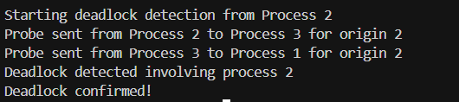

# **4. Enhanced Approach Deadlock Detection in the Chandy-Misra-Haas AND Model**

## **4.1. Overview**

The enhanced approach incorporates a DDFS-like mechanism along with improved state management and acknowledgment techniques. This hybrid model retains the core idea of probe-based detection while addressing shortcomings related to message loss, state tracking, and observability.

Key enhancements include:

* **Proactive Probe Initiation:** Processes periodically initiate probes, rather than waiting for suspicions.
* **Session-Based Tracking:** Probes carry unique session IDs and maintain a visited list, ensuring accurate tracking of each detection round.
* **Acknowledgment Mechanism:** Reliable message passing is ensured using acknowledgment channels and timeout-based retries.
* **Concurrency:** Leveraging Go’s goroutines and channels simulates asynchronous operations where each process manages its probe queue.

## **4.2. Algorithmic Approach and Data Structures Used**

* **Distributed Depth-First Search (DDFS):** A DFS-like mechanism is used to propagate probes and detect cycles. Each probe records its traversal path.
* **Maps:** Used for session-based state tracking (e.g., to mark processed sessions).
* **Channels:**
  + **Probe Channels:** Facilitate asynchronous message passing between processes.
  + **Acknowledgment Channels:** Confirm probe transmissions before proceeding.
* **Mutex and WaitGroup:** Ensure thread-safe access and synchronization among concurrent operations.
* **Slices:** Maintain the list of visited nodes to form the DFS traversal path.
* **Struct (Config):** Holds configuration parameters (e.g., probe intervals, timeouts) for flexible tuning.

## 4.3. Code Implementation

### 4.3.1 Go Routines

Below is the complete Goroutines code for the enhanced deadlock detection approach:

package main

import (

"context"

"fmt"

"log"

"os"

"os/signal"

"sync"

"syscall"

"time"

)

type Config struct {

ProbeInterval time.Duration

ChanBufferSize int

SimulationTime time.Duration

TimeoutDuration time.Duration

}

type Probe struct {

SessionID int

Initiator int

Sender int

Visited []int

AckChan chan bool

}

type Process struct {

ID int

successors []*Process

probeChan chan Probe

visited map[int]bool

config Config

mu sync.Mutex

wg sync.WaitGroup

stopChan chan struct{}

messagesSent int

deadlockCache map[int]bool

}

func NewProcess(id int, config Config) *Process {

return &Process{

ID: id,

probeChan: make(chan Probe, config.ChanBufferSize),

visited: make(map[int]bool),

deadlockCache: make(map[int]bool),

config: config,

stopChan: make(chan struct{}),

}

}

func (p *Process) Run(ctx context.Context) {

// Log the start of deadlock detection for this process.

log.Printf("Starting deadlock detection from Process %d, Visited: [%d]", p.ID, p.ID)

p.wg.Add(1)

defer p.wg.Done()

ticker := time.NewTicker(p.config.ProbeInterval)

defer ticker.Stop()

p.wg.Add(1)

go p.handleProbes(ctx)

for {

select {

case <-ctx.Done():

close(p.stopChan)

return

case <-ticker.C:

p.mu.Lock()

if len(p.successors) > 0 {

// Create a new session ID based on timestamp.

sessionID := int(time.Now().UnixNano())

p.visited[sessionID] = true

probe := Probe{

SessionID: sessionID,

Initiator: p.ID,

Sender: p.ID,

Visited: []int{p.ID},

AckChan: make(chan bool, len(p.successors)),

}

// Log initiation of probe including visited list.

log.Printf("Probe sent from Process %d to Process %d for origin %d, Visited: %v", p.ID, p.successors[0].ID, p.ID, probe.Visited)

p.mu.Unlock()

p.sendProbe(probe, ctx)

} else {

p.mu.Unlock()

}

}

}

}

func (p *Process) handleProbes(ctx context.Context) {

defer p.wg.Done()

for {

select {

case <-ctx.Done():

return

case probe := <-p.probeChan:

p.mu.Lock()

// Acknowledge receipt of the probe.

select {

case probe.AckChan <- true:

default:

}

// Check for deadlock: if the probe returns to its initiator.

if probe.Initiator == p.ID && !p.deadlockCache[probe.SessionID] {

log.Printf("Deadlock detected involving process %d, Visited: %v", p.ID, probe.Visited)

p.deadlockCache[probe.SessionID] = true

p.mu.Unlock()

log.Println("Deadlock confirmed!")

continue

}

// Forward the probe if not already processed.

if !p.visited[probe.SessionID] && len(p.successors) > 0 {

p.visited[probe.SessionID] = true

newProbe := Probe{

SessionID: probe.SessionID,

Initiator: probe.Initiator,

Sender: p.ID,

Visited: append(probe.Visited, p.ID),

AckChan: make(chan bool, len(p.successors)),

}

// Log forwarding of probe with the updated visited list.

log.Printf("Probe sent from Process %d to Process %d for origin %d, Visited: %v", p.ID, p.successors[0].ID, probe.Initiator, newProbe.Visited)

p.mu.Unlock()

p.sendProbe(newProbe, ctx)

} else {

p.mu.Unlock()

}

}

}

}

func (p *Process) sendProbe(probe Probe, ctx context.Context) {

select {

case <-p.stopChan:

return

default:

}

p.mu.Lock()

// Copy the list of successors to avoid race conditions.

successors := make([]*Process, len(p.successors))

copy(successors, p.successors)

p.mu.Unlock()

deadline := time.After(p.config.TimeoutDuration)

for _, succ := range successors {

select {

case succ.probeChan <- probe:

p.mu.Lock()

p.messagesSent++

p.mu.Unlock()

case <-deadline:

return

case <-ctx.Done():

return

}

}

// Wait for acknowledgments in a separate goroutine.

go func(expected int) {

acks := 0

for acks < expected {

select {

case <-probe.AckChan:

acks++

case <-deadline:

return

case <-ctx.Done():

return

}

}

}(len(successors))

}

func main() {

config := Config{

ProbeInterval: 10 * time.Second,

ChanBufferSize: 20,

SimulationTime: 30 * time.Second,

TimeoutDuration: 8 * time.Second,

}

// Create processes with cyclic dependencies: p0 → p1 → p2 → p3 → p0.

p0 := NewProcess(0, config)

p1 := NewProcess(1, config)

p2 := NewProcess(2, config)

p3 := NewProcess(3, config)

p0.successors = []*Process{p1}

p1.successors = []*Process{p2}

p2.successors = []*Process{p3}

p3.successors = []*Process{p0}

ctx, cancel := context.WithCancel(context.Background())

defer cancel()

// Listen for shutdown signals.

sigChan := make(chan os.Signal, 1)

signal.Notify(sigChan, syscall.SIGINT, syscall.SIGTERM)

go p0.Run(ctx)

go p1.Run(ctx)

go p2.Run(ctx)

go p3.Run(ctx)

select {

case <-time.After(config.SimulationTime):

log.Println("Simulation completed")

case <-sigChan:

log.Println("Shutdown signal received")

}

cancel()

p0.wg.Wait()

p1.wg.Wait()

p2.wg.Wait()

p3.wg.Wait()

fmt.Printf("Final Metrics: P0: %d messages sent, P1: %d messages sent, P2: %d messages sent, P3: %d messages sent\n",

p0.messagesSent, p1.messagesSent, p2.messagesSent, p3.messagesSent)

}

### 4.3.2 Go RPC

Below is the complete Go RPC code for the enhanced deadlock detection approach:

#### **4.3.2.1** Server.go:

package main

import (

"fmt"

"log"

"net"

"net/rpc"

"sort"

"sync"

)

// DeadlockRequest represents the RPC request for deadlock detection

type DeadlockRequest struct {

ProcessID int

}

// DeadlockResponse contains the result of deadlock detection

type DeadlockResponse struct {

Message string

DeadlockStatus string

MessageCounts map[int]int

TotalMessages int // New field to store total message count

}

// AddProcessRequest represents a request to add a new process dynamically

type AddProcessRequest struct {

ID int

Neighbors []int

}

// AddProcessResponse contains the response for adding a process

type AddProcessResponse struct {

Message string

}

// Process represents a node in the system

type Process struct {

ID int

Neighbors []int

}

// DeadlockService manages the processes and detection logic

type DeadlockService struct {

processes []*Process

mutex sync.Mutex

globalMessageCounter int

}

// DetectDeadlock handles RPC requests for deadlock detection

func (ds *DeadlockService) DetectDeadlock(req DeadlockRequest, res *DeadlockResponse) error {

if req.ProcessID < 0 || req.ProcessID >= len(ds.processes) {

res.Message = "Invalid Process ID"

return nil

}

start := req.ProcessID

log.Printf("Starting deadlock detection from Process %d, Visited: []", start)

visited := make(map[int]bool)

messageCounts := make(map[int]int)

localMessageCounter := 0 // Track messages for this request only

var deadlockDetected bool

var wg sync.WaitGroup

wg.Add(1)

go func() {

defer wg.Done()

ds.mutex.Lock()

defer ds.mutex.Unlock()

deadlockDetected = ds.runDDFS(start, start, visited, messageCounts, &localMessageCounter)

}()

wg.Wait() // Ensure detection is complete before responding

res.Message = fmt.Sprintf("Deadlock detection completed for Process %d", req.ProcessID)

res.MessageCounts = messageCounts

res.TotalMessages = localMessageCounter // Use request-specific counter

if deadlockDetected {

res.DeadlockStatus = "Deadlock confirmed!"

log.Printf("Deadlock detected involving Process %d, Visited: %v", start, getSortedVisitedList(visited))

} else {

res.DeadlockStatus = "No deadlock detected."

}

return nil

}

// runDDFS performs Distributed Depth-First Search (DDFS) to detect deadlocks

func (ds *DeadlockService) runDDFS(origin, current int, visited map[int]bool, messageCounts map[int]int, localCounter *int) bool {

visited[current] = true

for _, neighbor := range ds.processes[current].Neighbors {

messageCounts[origin]++

*localCounter++ // Increment request-specific counter

log.Printf("Probe sent from Process %d to Process %d for origin %d, Visited: %v", current, neighbor, origin, getSortedVisitedList(visited))

if neighbor == origin {

return true // Deadlock detected

}

if !visited[neighbor] {

if ds.runDDFS(origin, neighbor, visited, messageCounts, localCounter) {

return true

}

}

}

return false

}

// getSortedVisitedList formats the visited map into a sorted slice for logging

func getSortedVisitedList(visited map[int]bool) []int {

keys := make([]int, 0, len(visited))

for key := range visited {

keys = append(keys, key)

}

sort.Ints(keys)

return keys

}

// AddProcess allows dynamic addition of processes via RPC

func (ds *DeadlockService) AddProcess(req AddProcessRequest, res *AddProcessResponse) error {

ds.mutex.Lock()

defer ds.mutex.Unlock()

newProcess := &Process{ID: req.ID, Neighbors: req.Neighbors}

ds.processes = append(ds.processes, newProcess)

res.Message = fmt.Sprintf("Process %d added successfully!", req.ID)

log.Printf("Process %d added with neighbors %v", req.ID, req.Neighbors)

return nil

}

func main() {

// Define initial processes (circular dependency for testing deadlock)

processes := []*Process{

{ID: 0, Neighbors: []int{1}},

{ID: 1, Neighbors: []int{2}},

{ID: 2, Neighbors: []int{3}},

{ID: 3, Neighbors: []int{0}}, // Circular dependency

}

service := &DeadlockService{processes: processes}

// Start RPC server

rpc.Register(service)

listener, err := net.Listen("tcp", ":1234")

if err != nil {

log.Fatal("Error starting server:", err)

}

defer listener.Close()

log.Println("Deadlock detection server started on :1234")

for {

conn, err := listener.Accept()

if err != nil {

log.Println("Connection error:", err)

continue

}

go rpc.ServeConn(conn)

}

}

#### **4.3.2.1** Client.go:

package main

import (

"fmt"

"log"

"net/rpc"

"time"

)

// DeadlockRequest represents the request sent to the server

type DeadlockRequest struct {

ProcessID int

}

// DeadlockResponse represents the response received from the server

type DeadlockResponse struct {

Message string

DeadlockStatus string

MessageCounts map[int]int

TotalMessages int // New field

}

// AddProcessRequest represents a request to add a new process dynamically

type AddProcessRequest struct {

ID int

Neighbors []int

}

// AddProcessResponse represents the response for adding a process

type AddProcessResponse struct {

Message string

}

func main() {

client, err := rpc.Dial("tcp", "localhost:1234")

if err != nil {

log.Fatal("Client: Error connecting to server:", err)

}

defer client.Close()

// Optionally add a new process dynamically

newProcess := AddProcessRequest{ID: 4, Neighbors: []int{1}}

var addRes AddProcessResponse

err = client.Call("DeadlockService.AddProcess", newProcess, &addRes)

if err == nil {

log.Println("Client:", addRes.Message)

}

// Deadlock detection requests

testProcesses := []int{0, 2, 3}

for _, processID := range testProcesses {

startTime := time.Now()

log.Printf("Client: Sending deadlock detection request from Process %d...", processID)

req := DeadlockRequest{ProcessID: processID}

var res DeadlockResponse

err = client.Call("DeadlockService.DetectDeadlock", req, &res)

if err != nil {

log.Fatal("Client: RPC error:", err)

}

timeTaken := time.Since(startTime)

log.Printf("Client: Response received from server for Process %d", processID)

// Structured output

fmt.Printf("\n[Result for Process %d]\n", processID)

fmt.Printf(" ➤ Deadlock Status: %s\n", res.DeadlockStatus)

fmt.Printf(" ➤ Message Counts: %v\n", res.MessageCounts)

fmt.Printf(" ➤ Total Messages: %d\n", res.TotalMessages)

fmt.Printf(" ➤ Time Taken: %v\n\n", timeTaken)

}

}

## 4.4. How It Works

* **Process Behavior:** Each process periodically initiates a probe if it has successors. The probe includes a unique session ID and a visited list starting with the process itself.
* **Probe Propagation:** When a process receives a probe, it acknowledges it and checks if it is the initiator. If not—and if the probe has not already been processed—the process appends its ID to the visited list and forwards the probe.
* **Deadlock Detection:** A deadlock is detected when a probe returns to its initiator (i.e., when the initiator’s ID is encountered again in the visited list).
* **Message Reliability:** The use of acknowledgment channels and timeout-based retries ensures that message loss is mitigated, reducing the chance of false negatives or positives.
* **Metrics Collection:** Each process tracks the number of messages sent. These metrics are output at the end of the simulation to evaluate communication overhead.

## 4.5 Drawbacks Addressed

The traditional Chandy-Misra-Haas (CMH) AND model has several drawbacks that impact its efficiency, accuracy, and scalability in real-world distributed systems. The enhanced approach presented in this case study solves these limitations through improved algorithms and data structures.

### 1. High Message Overhead and Redundancy

* **Traditional CMH AND Model Issue:**
  + The original model relies on probe-based edge chasing, which can generate excessive probe messages, especially in systems with many processes and dependencies.
  + Redundant probes increase network congestion and computational overhead.
* **Enhanced Approach Solution:**
  + Implements **session-based tracking** to ensure that each probe is only forwarded once per session, significantly reducing unnecessary messages.
  + Uses **acknowledgment channels** to confirm received probes before forwarding new ones, eliminating duplicate probe transmissions.
* **Impact:**
  + Reduces network traffic and improves efficiency.
  + Minimizes redundant processing, leading to faster deadlock detection.

### 2. Sensitivity to Network Delays and Message Loss

* **Traditional CMH AND Model Issue:**
  + The original model assumes that messages arrive reliably, which is not always the case in real distributed environments.
  + Lost or delayed messages can lead to **false negatives** (missed deadlocks) or delayed detection.
* **Enhanced Approach Solution:**
  + Introduces **timeout-based retries** to ensure probes are resent if acknowledgments are not received within a given time.
  + Uses **concurrent message handling** via Go’s goroutines and channels to asynchronously process probe transmissions, reducing the risk of delays.
* **Impact:**
  + Ensures reliable probe propagation even under network instability.
  + Provides robust deadlock detection with minimal false negatives.

### 3. Poor Observability and Debugging Challenges

* **Traditional CMH AND Model Issue:**
  + The original algorithm provides little visibility into probe propagation, making it difficult to trace how deadlocks are detected.
  + Debugging is challenging because there is no record of the visited path of probes.
* **Enhanced Approach Solution:**
  + Maintains a **detailed visited list** within each probe, allowing full visibility of how probes propagate through the system.
  + Logs every probe transmission, including **sender, receiver, session ID, and visited nodes**, enabling **real-time monitoring and debugging**.
* **Impact:**
  + Improves transparency of deadlock detection.
  + Makes it easier to diagnose system behavior and optimize performance.

### 4. Inefficiency in Highly Dynamic Distributed Systems

* **Traditional CMH AND Model Issue:**
  + The model struggles with frequent process additions, removals, or changes in resource allocation.
  + Static probe initiation (only on suspicion) can lead to **delayed or missed** deadlock detections.
* **Enhanced Approach Solution:**
  + Uses **proactive periodic probe initiation**, meaning that processes regularly initiate detection without waiting for suspicion.
  + Enables **concurrent detection rounds**, allowing multiple independent deadlock detections to run simultaneously.
* **Impact:**
  + Detects deadlocks **earlier** rather than waiting for a process to suspect a blockage.
  + Scales better in environments where process dependencies change frequently.

### 5. Lack of Scalability in Large Systems

* **Traditional CMH AND Model Issue:**
  + The probe-based approach becomes inefficient when applied to systems with a large number of processes and dependencies.
  + The algorithm's complexity increases as the number of processes grows.
* **Enhanced Approach Solution:**
  + Implements **distributed depth-first search (DDFS)-style** probe traversal to optimize cycle detection.
  + Uses **efficient data structures (maps, slices, and acknowledgment channels)** to reduce the overhead of tracking dependencies.
* **Impact:**
  + Makes deadlock detection feasible in large-scale distributed systems.
  + Reduces the overall computational and memory footprint.

## 4.6. Output Example

For example, in one run:

* P2 initiates a probe that gets forwarded as:  
   [2] → [2, 3] → [2, 3, 0] → [2, 3, 0, 1]  
   When the cycle completes, P2 detects the deadlock.
* In another round, P1’s probe travels as:  
   [1] → [1, 2] → [1, 2, 3] → [1, 2, 3, 0]  
   And P1 detects the cycle.
* Final metrics might show each process sent 4 messages during the simulation.

### 4.6.1 Go Routines:

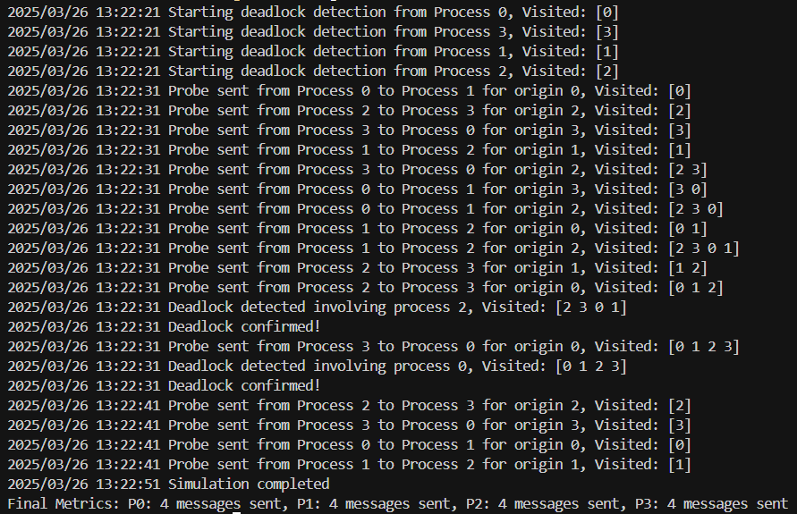

### 4.6.2 Go RPC:

Server:

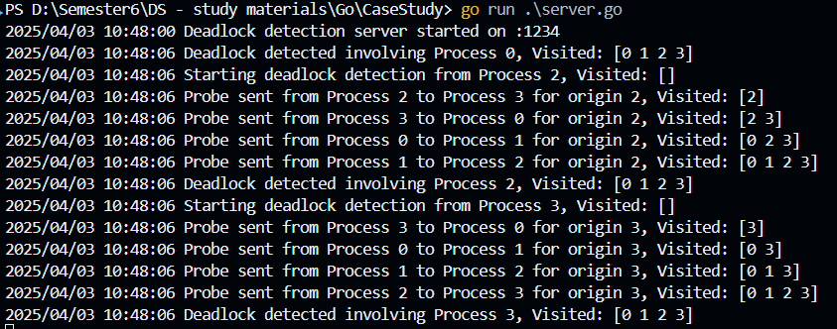

Client:

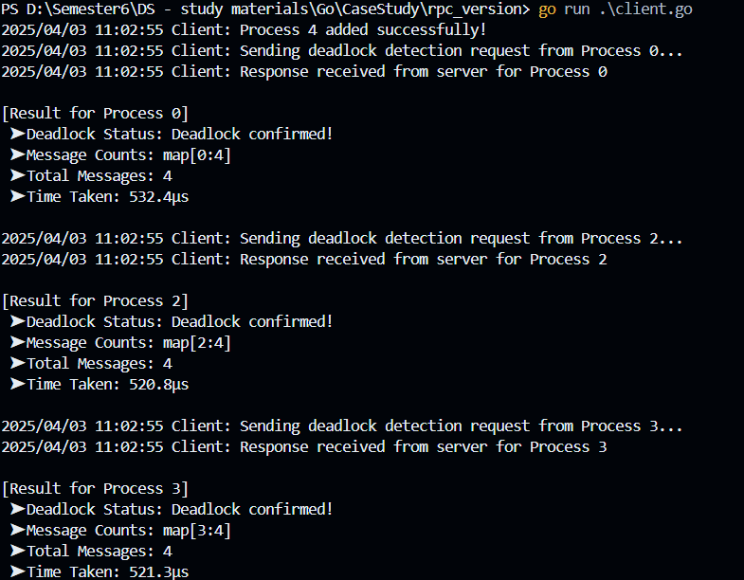

**5. Comparison: Traditional vs. Modified Hybrid Approach**

## **5.1. Mechanism**

* **Traditional CMH:** Relies on probe messages traversing the wait-for graph. A probe returning to its origin indicates a cycle (deadlock).
* **Hybrid Approach:** Combines proactive, periodic probe initiation with a DFS-like traversal using session IDs and acknowledgment channels. This method adds structured state tracking to reduce redundant messaging.

## **5.2. Efficiency**

* **Traditional Approach:** High message overhead may occur because every process continuously forwards probes without filtering redundant ones.
* **Hybrid Approach:** The session-based tracking and acknowledgment mechanism ensures that only unprocessed probes are forwarded. Concurrency, timeouts, and retries help minimize redundant messages.

## **5.3. Accuracy & Robustness**

* **Traditional Approach:** Sensitive to network delays, which can cause false positives or negatives in deadlock detection.
* **Hybrid Approach:** Robust against message loss and delays through acknowledgment channels and retry logic. Detailed logging and metrics further improve the system’s observability and debugging capability.

## **5.4 Trade-offs and Justification**

* **Complexity vs. Reliability:** The enhanced approach is more complex due to additional concurrency management, session tracking, and acknowledgment handling. However, this complexity is justified by improved detection speed, reduced false detections, and better handling of asynchronous events.
* **Data Structures:** The use of maps for state tracking and slices for maintaining probe paths provides efficient access and minimal overhead compared to simpler, unstructured approaches. This choice is key to reducing message traffic and ensuring scalability in larger, dynamic networks.

## **5.5 Side-by-Side Comparison**

| **Aspect** | **Traditional CMH AND Model** | **Enhanced Hybrid Approach** |
| --- | --- | --- |
| **Mechanism** | Probe-based edge chasing in a wait-for graph. | Proactive, periodic probe initiation with session tracking. |
| **Probe Propagation** | Unfiltered forwarding along waiting-for edges. | DFS-like traversal with acknowledgment and session-based filtering. |
| **Message Overhead** | Potentially high due to redundant probe forwarding. | Reduced overhead with targeted probe forwarding and retries. |
| **Robustness** | Sensitive to network delays and message loss. | Improved reliability via timeouts, retries, and detailed logging. |
| **Implementation** | Simpler design; easier to implement but limited scalability. | More complex with concurrency controls and state management, enabling better scalability. |
| **Observability** | Limited; difficult to diagnose issues in real time. | Enhanced logging and metrics provide deeper insights into system performance. |

# **7. Conclusion**

The enhanced hybrid approach improves upon the traditional Chandy-Misra-Haas algorithm by introducing proactive probe initiation, session-based state tracking, and reliable message acknowledgment. These improvements address key limitations such as excessive message overhead, sensitivity to network delays, and poor observability. By combining a DFS-like traversal with robust data structures and concurrency controls, the proposed solution offers a more dependable and efficient deadlock detection mechanism in dynamic distributed environments.